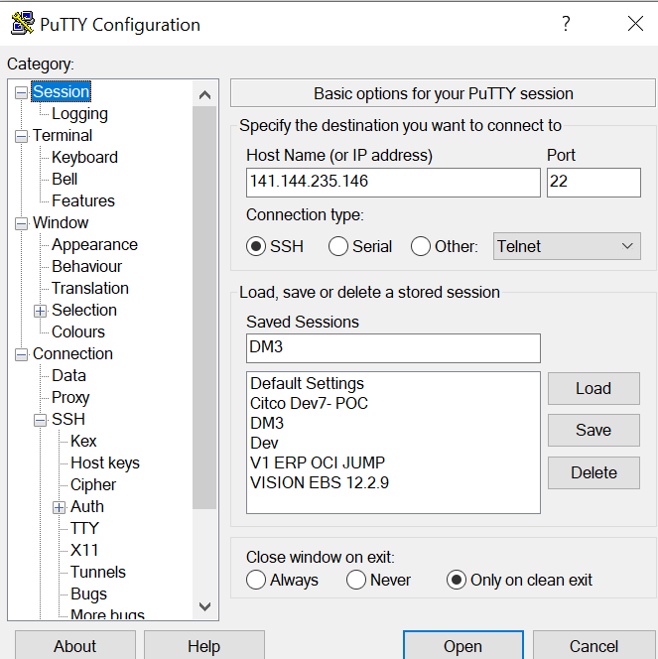

z

PuTTY-User-Key-File



Destination: 10.0.1.206:1521

SQL Connection:

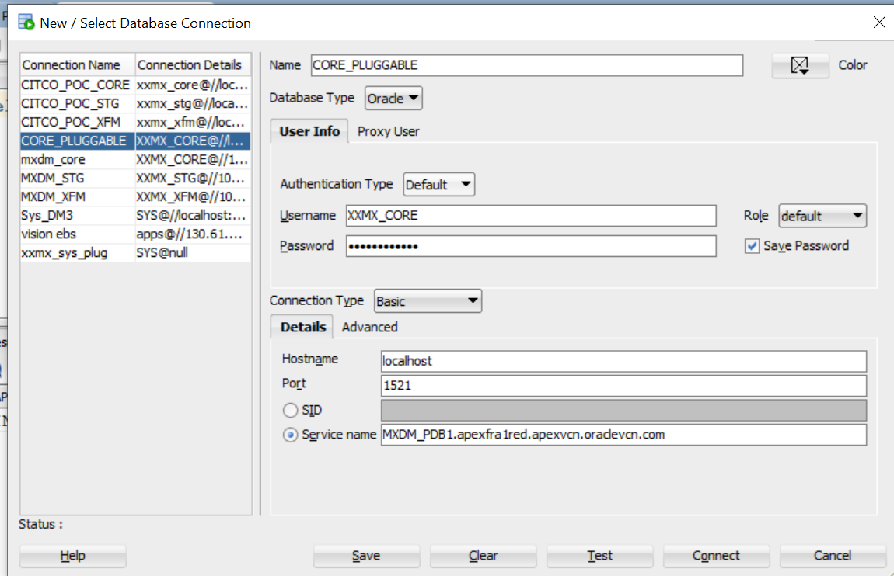

MXDM_PDB1.apexfra1red.apexvcn.oraclevcn.com